Qualitative Longitudinal Research with Children and Young People

Gina Crivello, Young Lives, Oxford Department of International Development, University of Oxford, Oxford, UK

Email: gina.crivello@qeh.ox.ac.uk

This is the pre-proofed, pre-publication version. The final version is available here:

‘Qualitative Longitudinal Research with Children and Young People’

Evans, R. and Holt, L. (eds) Methodological Approaches, Geographies of Children and Young People, Volume 2, in Skelton, T. (editor-in-chief) Geographies of Children and Young People. (Springer Singapore)
© Springer Science+Business Media Singapore 2015

Abstract
There is growing interest in the potential value of qualitative longitudinal research (QLR) for shedding light on temporal dimensions of experience, and on the way personal biographies are shaped by social structures and processes over time. This chapter outlines some of the definitions, designs, advantages and challenges in relation to QLR, focusing on ways of engaging children and young people. It offers three examples of QLR, and describes a selection of methodological tools and techniques for accessing children’s perspectives on their lives, trajectories and social worlds, across time. The chapter underscores the academic and ethical value in involving children in QLR, at the same time bringing to light the complex practical and ethical challenges stemming from their participation.
Keywords: qualitative methodology, longitudinal research, methods, children and youth, ethics

Introduction
Till now no one has discussed like this with children. We feel happy that members of the research team mingle with us. Earlier we never spoke up before anybody. But now we are able to speak out in front of people like you without any fear, and this helped us in having courage, and now I know what I will become in my future. Within these two years, we come to know how to speak with elders.
(13-year old boy, India, Young Lives study)

Engaging children and young people in qualitative longitudinal research (QLR) generates diverse methodological and ethical challenges (Morrow 2009). Longitudinal research exacerbates quandaries generally inherent in qualitative research with children, such that managing power dynamics between adult researchers and young participants becomes a long-term process, beyond ‘one-off’ research encounters. The amount of data grows with each round of data collection, and personal relationships may deepen and complicate over time. Contextual factors are vital in shaping children’s involvement, since in many societies seeking children’s perspectives in research is considered at odds with local mores and hierarchies, and yet, in other contexts, children may feel at ease being interviewed and the notion of filling out a survey questionnaire may be (or come to be) familiar to them. Context also influences the potential impact that research participation has on those individuals and groups who participate, as indicated by the above quote.

There is, however, tremendous value in involving children in longitudinal research, and the complexities underpinning QLR introduce unique opportunities for exploring the interaction between social and individual change across space and time. This chapter describes concepts, tools and techniques for engaging children and young people in QLR, particularly in light of developments within the past few decades that recast children as valid and valuable participants within social research. Two developments stand out: the first is the movement around children’s rights and the role of the United Nations Convention on the Rights of the Child (UNCRC) in framing all children as rights holders, including with rights to participation (Clark 2005:489). The second is the emergence of an academic social studies of childhood that reconceptualised children ‘as beings not becomings’ (Qvortrup 1994:2), and that moved the focus away from future-oriented socialisation processes towards children’s perspectives on their everyday lives in the ‘here and now’ (Mayall 2002). Greene and Hill (2005:2) reflect:
As one looks from an historical perspective at the vast field of social scientific, empirical research already conducted on and with children, it is evident that the predominant emphasis has been on children as objects of research rather than children as subjects, on child-related outcomes rather than child-related processes and on child variables rather than children as persons.

Childhood studies is an interdisciplinary field, including perspectives from anthropology, cultural studies, history, sociology and geography; and although most research centres on Euro-American childhoods, there is a burgeoning international literature describing childhood in low- and middle-income countries, and analysis of the way global and international structures shape childhood in different contexts (c.f. Abebe 2008a; Katz 2004). One of the major contributions of children’s geographies to this re-imagining of childhood has been exploration of the centrality of space and place in the everyday lives of children. Places are important for young people because identities are constituted in and through particular spaces (Holloway and Valentine 2000:770), and because they ‘play a large part in constructing and constraining dreams and practices’ (Aitken 2001:20). Children’s geographers draw on the main tenets of childhood studies to consider the way social constructions of childhood are also spatial constructions. Children are regarded as social actors, negotiating agency within the context and constraints of particular spaces and places. In light of these achievements drawing attention to space and place, in recent years, there has been a call within geography to introduce a greater focus on temporality (Cole and Durham 2008), and on time-spaces ‘to move beyond the individual, to see young people in relation to their wider contexts and in particular their relationship with others, as these shape outcomes’ (Ansell et al 2011:541).

Such developments have been accompanied by important methodological advancements aiming to strengthen the participation of children in both academic and practice-oriented research (c.f. Boyden and Ennew 1997; Clark 2005; Clark et al 2014; Johnson et al 2014; Morrow and Crivello 2015; Punch 2001; van Blerk and Kesby 2009). This chapter draws on these advances and describes how particular tools and techniques have been used (or may be adapted for use) within the context of longitudinal research design. The next section defines qualitative longitudinal research before moving on to a discussion of why and how this methodology may be used to study different aspects of childhood and youth experience, followed by three brief case examples. A selection of specific tools and techniques are described, before moving on to the final section which reflects on some of the practical and ethical considerations that arise when carrying out QLR with children in different contexts.

What is qualitative longitudinal research?
There is a well-established tradition of quantitative longitudinal research in social science, which has been facilitated by the growth of large panel data sets, for example the Birth Cohort Studies in the UK, Birth to Twenty in South Africa, the Gansu Survey of Children and Families in China, and the dual- cohort study of childhood poverty, Young Lives, in Ethiopia, India (Andhra Pradesh and Telangana states), Peru and Vietnam. In comparison, the development of qualitative longitudinal research is in its infancy, much of the innovation stemming from initiatives and networks based in the United Kingdom and other wealthy countries where the majority of the research takes place. Qualitative longitudinal research with children in low- and middle-income countries is relatively rare.
But what is qualitative longitudinal research? There are many definitions and models, such that each study is context specific and motivated by a particular set of goals, concepts, research questions and funding constraints. Time, change and duration underpin many definitions of QLR, reflecting ‘the deliberate way in which temporality is designed into the research process making change a central focus of analytic attention’ (Thomson and Holland 2003:185). Neale & Flowerdew (2003:190) suggest that, ‘It is through time that we can begin to grasp the nature of social change, the mechanisms and strategies used by individuals to generate and manage change in their personal lives, and the ways in which structural change impacts on the lives of individuals’. Time, nonetheless, remains a ‘sometimes forgotten aspect of the research process’ (Green and Hill 2005:17).
Time is inherent in QLR in two ways: first, in the design, since data are generated through multiple research encounters (Henwood and Shirani 2012:1); and second, as an analytic theme through exploration of temporal dimensions of experience, from the biographical and the generational to the historical (Adam et al 2008:7; Neale 2012:2). QLR has been referred to as ‘a particular theoretical orientation, a way of knowing and understanding the social world’ (Neale and Flowerdew 2003:189). Macmillan (2011:5) asks, by extending the analytical timeframe, ‘might things be seen differently, or different things seen?’ The suggestion is that QLR opens a space for flexibility, adaptation and innovation, these characteristics determined to be methodological advantages rather than weaknesses (Thomson and Holland 2003:234). Saldaña suggests that, ‘we should be flexible and allow a definition of change to emerge as a study proceeds and its data are analysed. Ironically yet fittingly, we should permit ourselves to change our meaning of change as a study progresses’ (Saldaña 2003:12).
There are many models of QLR (see Holland et al 2004 for a review). These include:
- Periodic revisits to the same sample or community at regular or irregular intervals. An example is the anthropological study carried out by Jeannine Anderson (2007) in a poor neighbourhood in Lima, Peru; through a series of visits, she followed a sample of 56 families over a 30 year period, examining poverty dynamics and intergenerational change. In the UK, the ESRC Timescapes program was the first major qualitative longitudinal study to be funded in the UK, developing a series of planned prospective qualitative longitudinal studies to explore how personal and family relationships develop and change over time; particular projects focused on siblings and friends, motherhood and fatherhood, transitions to adulthood, family lives, and older generations. [1]
- Repeating a ‘classic’ study in the same community after a lengthy interval has elapsed, possibly with new researchers not involved in the original study. For example, ‘Living and Working on Sheppey: Past, Present and Future’ was a follow-up study on research undertaken by Ray Pahl and colleagues three decades earlier on the Isle of Sheppey. The new study revisited some of Pahl’s archived material, collected new data and worked closely with community members. One area of analysis drew on new and old data sets to examine the imagined futures of young people on the island and changes over time (Lyon and Crow 2012).
- Mixed methods approaches where qualitative longitudinal elements are intertwined with a quantitative study. An example, discussed in further detail below is Young Lives, a fifteen-year survey study of childhood poverty being carried out in Ethiopia, India, Peru and Vietnam that includes a seven-year longitudinal qualitative strand with a nested sample of children (Wilson and Huttly 2003). [2]
- Ethnographic research where there is long-term continuous engagement with a community. For example, Margaret Mead’s classic study of Samoan adolescence, Coming of Age in Samoa (1928) was based on nine months of participant-observation among the island’s young people. More recently, Ruth Emond employed an ethnographic approach in her study of children’s experiences living in a Scottish children’s home; initially, she planned to make periodic research visits to carry out interviews, but early on the children insisted that if she wanted to understand their lives she needed more than a ‘snapshot’ and should therefore live alongside them in the home (Emond 2005).
- Evaluation and tracking research. In the UK, there is growing interest in the value of qualitative longitudinal analysis to evaluate policy change (e.g., Clark and Fox 2012; Lewis 2007; Millar 2007). For example, Ridge and Millar (2011) studied working lone mothers and their children living on low-incomes, repeating interviews with them over a period of three to four years, locating their family experience within the context of wider policy shifts and labour market forces.
Moreover, the design of QLR can be either prospective or retrospective in capturing the temporal dimension of experience. In prospective studies, individuals, groups or institutions are tracked in ‘real’ time, recording change as it occurs (e.g., in successive rounds or through long-term ethnography), whereas in retrospective studies, researchers rely on participants’ recreations of the past, using life history methods and other techniques of memory to explain life up to the present (Laub and Sampson 2003). Others distinguish between synchronic and diachronic perspectives, the latter adding depth to cross-sectional analysis. In Hay’s words (2002:149):
If the synchronic approach is analogous to the taking of a photograph at a particular instant … the diachronic approach is the equivalent of a video ‘panning’ shot which follows the motion of the object in question.
In practice, QLR may combine synchronic and diachronic analyses, and both retrospection and prospection -- for instance in prospective studies that ask participants to reflect on changes and continuities since the last visit and to engage in life history work. And in the analytic phase of QLR, the first step is often cross-sectional (synchronic) analysis of the latest round of data, followed by a second phase of longitudinal (diachronic) analysis (see Thomson 2007 on the construction of longitudinal case histories).
The next section turns the focus to the involvement of children and young people, followed by three brief examples from research.

Children and Young People in QLR
A plethora of child-focused methods for involving children in research has been developed in tandem with the growth of childhood studies, and alongside mounting interest by NGOs and INGOs in ‘children’s participation’ in a range of research and practice initiatives. But not all research necessitates children’s participation, and in some cases there may be an ethical case for excluding young people, for example, on the grounds that their participation might put them at risk, be exploitative, or cause them emotional distress. Not all research questions require a longitudinal design, whilst some topics are particularly well-suited to QLR, such as those seeking to understand change and continuity, process and causality, as in life course research focusing on transitions, turning points and biographical change (see Holland et al 2004:14). Less innovation and reflection has been recorded in the area of children’s participation in qualitative longitudinal research, perhaps because the particular methods used may be similar to those used in ‘one-off’ qualitative studies, and it may be more a question of how individual methods are combined or used over time to answer particular questions.
Substantive areas of investigation that might benefit from a qualitative longitudinal design relate to:
- Transitions: life course issues, such as status and role changes across time and space; ‘critical moments’ and what motivates decisions, e.g., in the movement from primary to secondary school, or in transitions to adulthood
- Identity construction: identity formation across childhood; the way individual biographies evolve in the context of wider social processes and change
- Resilience: children’s experience of risk over time and the protective processes that promote resilience
- Family lives: the intersection between personal and family lives and social structures; the impact of key life events, household shocks or policy shifts on changing family relationships and children’s wellbeing
- The study of specific processes: such as migration or poverty dynamics
- Careers of particular categories or groups: tracking the life trajectories of ‘street children’, ‘child-headed households’ or of young people at risk of offending
- Impact of development programs: documenting medium and longer-term experiences and outcomes of particular interventions into children’s lives, families and communities (such as the impact on children of participation in international child sponsorship programs)
- Trends: cultural shifts and changes in values and attitudes over time; changing conceptualizations of childhood
Several longitudinal studies have taken a child or youth focus, reflecting interest in child development, social change and life course processes linking earlier circumstances with later outcomes. Werner and Smith’s seminal Kauai longitudinal study of resilience stands out; in 1955 they initiated a four-decade long study of the Hawaiian island’s entire birth cohort population, including many children born into difficult family circumstances. The study combined quantitative and qualitative approaches, finding that many young people who had experienced adversity early in life were able to flourish in adulthood, and that supportive relationships and new opportunities were among the key factors protecting them from adversity (Werner and Smith 1992; 2001).
Children’s participation in QLR can take different forms – children may be the primary ‘subject’ being tracked over time, as in a birth cohort study – or they may participate in QLR on the basis of their membership in a larger unit, such as a particular sample of families, schools or communities, being tracked longitudinally. . Thomson and colleagues (2012) reflect on how the nature of participation of children in a longitudinal qualitative study of new mothering in the UK changed over time; although the study was designed to empirically focus on the new mother, researcher observations in successive rounds of research recorded the ‘emergence of the child’ as an increasingly active presence in the study (from the pre-natal stage into the early years of life).

Examples from research
This section describes three cases of research engaging children and young people in QLR, each representing a different approach or model: Inventing Adulthoods is a planned prospective study of transitions to adulthood in the UK; Young Lives is a mixed methods investigation of childhood poverty in four developing country contexts; and, Samantha Punch’s research following a group of Bolivian children resembles an ethnographic approach.
- Inventing Adulthoods emerged through adaptation and innovation (Thomson and Holland 2003: 234), growing out of an earlier (3-year) research program on ‘Youth Values: Identity, Diversity and Social Change’ that involved young people (aged 11-16) growing up in five contrasting locations in the UK. Inventing Adulthoods followed-up on a sub-sample of 120 of the original ‘Youth Values’ participants, and interviewed them at 9-month intervals over a further 3-year period. The purpose was to explore the process of identity change, and the factors shaping young lives and pathways over time. The off-shoot study was eventually extended further (adding a third phase) so that ultimately the young people were followed over a decade (1996-2006), from as young as 11 years old, into the transition to adulthood. [3]

The core method across the three phases was the repeat biographical interview (up to six over the course of the study) which was combined with various ethnographic techniques and group discussions (Thomson and Holland 2005). For example, researchers in the first interview invited young people to compile memory books (a form of open diary or scrapbook) that later served as a talking point come the second round interview. Similarly, lifelines completed in the first interview were revisited in the third interview.

- Young Lives is an international study of childhood poverty following the changing lives of 12,000 children in Ethiopia, India (in Andhra Pradesh and Telangana states), Peru and Vietnam over 15 years. The study tracks the life trajectories of two age-cohorts of children born in 2001 and 1994 through complementary panel survey and QLR components (the author is a Senior Qualitative Researcher within Young Lives and leads on the QLR component). Researchers administer surveys to the full sample every few years: to the children/youth (above 8 years old), their caregivers and community members. The qualitative component works with a nested sample of some 200 children recruited from both cohorts, with four rounds of data collection spanning a seven-year period. It documents children’s (and caregivers’) everyday experiences of poverty through detailed narrative accounts, reflecting on their childhoods (past, present and future), including their perspectives on what has contributed to shaping their situations, trajectories and well-being, their aspirations and goals, as well as realistic expectations for future outcomes.

The QLR component adopted a methods ‘toolkit’ approach so that local research teams in the four study countries could select from a suite of methods and adapt them for use with children in different contexts: life course time lines, community mapping, mobile interviews and child-led walks, vignettes and story completion, body mapping, drawings, video and photo-elicitation, time-use diaries and a ‘wellbeing’ exercise generating indicators of child wellbeing and illbeing with children (for a review see Crivello el al 2013). These creative tools complement semi-structured interviews with children, caregivers and community members at each round. Several of the tools have been repeated across different rounds to enable reflection and analysis of change. The data generate longitudinal case studies and analyses which are contextualized by statistics from the large-scale quantitative Young Lives survey.

- Samantha Punch’s research following a group of children from a rural community in southern Bolivia spanned a ten-year period, comprising two main periods of fieldwork combining ethnographic and interview-based approaches (Punch 2012). The first phase was PhD fieldwork, an ethnographic study of rural childhoods in Bolivia, exploring how children negotiate autonomy in their everyday lives at home, work, play and school. This phase consisted of Punch living in a rural community for extended periods of time over a two-year period, beginning in 1993.

Punch employed a range of qualitative methods to engage children and families, including semi-structured interviews and (semi-) participant-observation. The study included classroom observations and task-based methods with children (aged 6 – 14), consisting of children writing diaries, taking photographs, drawing pictures, completing worksheets and creating spider diagrams and activity tables (see Punch 2001).

Although the longitudinal element was not originally built into her original doctoral research design, ten years later, Punch undertook a four-month follow-up study in the original community (Bolivia) and in Argentina where many of the young people had migrated; this entailed tracing 14 of the original 18 sample households. This phase relied on semi-structured interviews alongside some participant-observation in the migrant destinations. The follow-up study shifted focus to child/youth migration, and to the impact of wider social changes -- such as Argentina’s economic crisis in 2002 – on young people’s decisions to migrate, or not.

Like many researchers who develop close ties with particular families and communities, Punch had always hoped to be able to return to her original study village, but initially, time and funds did not permit her to include a second follow-up phase in the doctoral research design. She reflects that it would have been preferable to have carried out an interim study after five-years, rather than leaving a ten-year gap, since interviews relied heavily on retrospection to capture decisions made over the ten-year period. The second research phase, however, benefited enormously from research relations established in the first phase of the study in terms of rapport and practical and logistical help accessing communities and tracking down her original sample of children.

Methods, techniques, tools
The three examples (above) represent different ways of engaging children and young people in QLR, yet they demonstrate similarities (each study combining interviews with an ethnographic approach), including shared use of particular tools, such as diaries and visual methods (photos/videos). The studies were flexible in their approach and development and drew on multiple methods, adapting questions and techniques to reflect changes in children’s lives, capacities, interests and circumstances. The three studies illustrate how ‘time’ is captured in different ways through QLR with young people, often entailing the combination of prospective and retrospective techniques. Drawing on these and other studies, this section briefly describes a selection of specific tools that can be adapted for use with children in QLR.
Baselines and change
The first round of data collection in a QL study serves as a ‘baseline’ against which subsequent change and continuity can be detected and interpreted. It is therefore vital from the outset to have a clear understanding of what it is the study is tracking over time, as well as a vision of the conceptual and methodological ‘threads’ that might tie the rounds together to produce something greater than the sum of a series of cross-sectional snapshots (i.e., the ‘movie’ rather than the stack of ‘photos’).
Much QLR draws on more than one source of data. QLR involving children are often undertaken using the same individual methods employed in cross-sectional research, although methods eliciting temporal data (such as timelines) may be particularly instrumental in the former; the distinction in QLR often comes in the way methods are used ‘temporally’ – through re-use and repetition across rounds (discussed below). The methods available for use in QLR are seemingly endless and only limited by time, imagination and the studies’ particular research goals. Some of the more common methods that have been used with children are listed here:
Biographical interviews:
The repeat biographical interview is often the cornerstone of the QL methodological toolkit, including in child-focused research in which the ‘subject’ being tracked and analysed is ‘the child’. Biographical interviews can take a range of formats including structured, semi-structured, unstructured and ‘open-ended’. Semi-structured interviews are particularly common in qualitative research and enable in-depth exploration of personal perspectives (Bryman 2004) and the recording of individual biographies as they unfold over time. There may be an additional moral value when using interview-based methods to capture the ‘voices’ of children representing marginalized or ‘hard-to-reach’ populations whose perspectives often remain muted in research (such as undocumented immigrants or young carers).
Although interviews have been extensively used in research with young people (Wright, O’Flynn & MacDonald, 2006; Johansson, Brunnberg & Eriksson, 2007), there are many practical and ethical factors to consider. The decision to interview very young children (under 8) requires special consideration and exploration of possible alternative methods that may better reflect their preferred modes of communication (Clark 2005; Johnson 2014). For instance, in the first round of Young Lives QLR in 2007, researchers arranged ‘interviews’ with the youngest cohort of children who were 5-6 years old at the time. The semi-structured interview protocols could only be used as a loose guide, and the more traditional ‘one-on-one’, question-answer format, did not yield rich data. A benefit of these early research encounters with children was to build rapport, and to gain a basic sense of children’s personalities, as well as their likes/dislikes, daily routines and relationships. Indeed, these were rarely ‘one-on-one’ interviews, children often preferring to be with their mothers or another family member during the interview at home. However, the same children participated on their own (without family) in group-based discussions (involving drawing) with other children their age; and the semi-structured interview format generally worked well with the older children, aged 12, in the first wave of data collection.
Researchers have debated the advantages and disadvantages of interviewing children on their own, in pairs and in groups, both in terms of the quality of data generated and the way children experience the research encounter (Broström 2005; Einarsdóttir 2007). Interviewing children in pairs and groups may offer a sense of safety and security, and an opportunity to socialise. There may be circumstances when researchers wish to avoid eliciting children’s ‘personal stories’, and prefer collective accounts on sensitive topics, like community-based violence (c.f., Veale 2005:255). Focus groups can be reconvened to make them longitudinal, but careful recording procedures are required to enable tracking of individual perspectives within group-generated accounts.
Biographical interviews can be combined with any number of creative, mobile and graphic elicitation tools to aid the flow and record of conversations with children – these range from audio-diaries (Worth 2009) and photo-elicitation (Morrow 2001), to mobility maps and tours (Walker forthcoming), story-writing (Abebe 2008b) and story-telling and vignettes (Barter and Renold 2000). Hanna and Lau-Clayton (2012:1) posit, ‘Not only can these methods add depth, but they can be a means of accession, offering the researcher a ‘way in’ to more complex dimensions of experience that participants may find difficult to conceptualise or verbalise.’
The incorporation of drawing or mobile activities may allow for pauses and silences in conversation, thus breaking up the intensity of one-on-one verbal exchange (Guenette and Marshall 2009). Creative elicitation tools may influence the power balance in research encounters between adults and children, in some cases awarding children greater scope for directing the flow of conversation, and in other cases helping the researcher to maintain control during the interview (c.f. Varga-Atkins and O’Brian 2009). Importantly, it is the conversation that is generated from use of these tools, rather than the visual (or other) prompts themselves, that remain the core output for analysis.

Timelines:
Timelines (also known as life maps, life grids, life lines and life course timelines) can be effective tools within the context of biographical and life history interviews exploring individual experiences of past, present and future. Timelines offer a way for participants to narrate life stories and sensitive events, to identify key milestones and turning points and to generate new meanings and understandings (Ansell et al 2011; Gabb 2008; Guenette and Marshall 2009; Hanna and Lau-Clayton 2012; Worth 2009).
Timelines can be constructed in numerous ways, often simply depicted as a horizontal line across a page which may be demarcated for different ages or years. Participants are then invited to record significant events and milestones from birth to present, and to indicate expectations for the future. Variations have been used with young people in diverse contexts, including a study in Malawi and Lesotho exploring the life course trajectories and differential outcomes of AIDS-affected young people, recording their changing relationships across time and space (Ansell et al 2011).
In a different study, by Timescapes, timelines were used to explore young people’s narratives about their past and present (in the first wave of data collection) and about their projections and expectations about their future lives (in the second wave) (Bagnoli 2009:560). Young people were also asked to include on their timelines any significant events that had happened in the wider world that may have been influential in shaping their life trajectories. In Young Lives, children were invited to write ‘positive’ memories above the line, and ‘negative’ or ‘difficult’ memories below, this enabling researchers to follow-up with questions about the sources of support children accessed in times of difficulty.
[INSERT TIMELINE PHOTO HERE] [Photo caption: Photo of a timeline created with ‘Ayu’, a 12 year-old girl in Ethiopia. Young Lives (2007)]
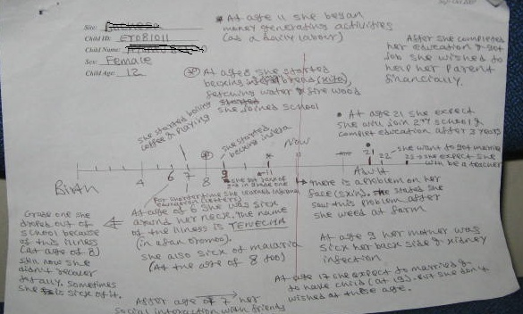
The example here, from Young Lives, is of a timeline generated with ‘Ayu’, a girl, around aged 12, in Ethiopia, during the first wave of data collection in 2007. Low levels of literacy meant that many of the children required assistance, including Ayu. The timeline was generated collaboratively with the researcher who, in this case, wrote the text in the third-person. The discussion that happened around the drawing of the timeline was recorded, transcribed and translated for analysis.
RESEARCHER: Can you write?
AYU: No, can I tell you what to write and you write it for me?
RESEARCHER: Shall I write for you?
AYU: Yes.
In this study, timelines were useful for exploring with children the time-space dimensions of their experience past, present and future. In the first wave of data collection, timelines also served as a kind of baseline in order to explore change during subsequent research visits. In Ayu’s timeline, we discovered that many of her childhood memories were associated with illness, including malaria, a facial rash, and a chronic swelling of the neck, all of which resulted in her missing school.
The timeline was also useful to capture Ayu’s changing roles, responsibilities and time-use, the relationship between schooling, housework and paid work, and how she felt.
RESEARCHER: When did you start to work? What kinds of work have you done?
AYU: When I started school at eight, I also started to work at home.
RESEARCHER: What activities did you start to do?
AYU: Baking injera [local bread] and preparing coffee.
RESEARCHER: Do you bake injera now?
AYU: Yes… I started at eight. I also fetch water and collect fire wood, and go wherever mother sends me
Ayu talked about her time-use in the context of her family relationships.
AYU: I am happy in my working and my education. I am very happy with the daily work because I get money.

RESEARCHER: Why does that make you happy?

AYU: When I get money, even my parents are happy. At the beginning my parents prevented me from doing daily work but now they are happy with what I am doing.

The timeline exercise elicited Ayu’s hopes and views for the future regarding school, work and marriage. Her aspiration at age twelve was to become a teacher and she was not much interested in marriage.
RESEARCHER: At what age do you think that you will get married?
AYU: [Laughter] I don’t want to get married, but my parents may force me to get married.
RESEARCHER: Don’t you want to get married?
AYU : Yes.
RESEARCHER: Why?
AYU: Education is better for me…[I] don’t have interest to get married. But my parents may force me to marry.
…
RESEARCHER: When do you want to get married exactly?
AYU: At 22.
RESEARCHER: Why did you choose that age?
AYU: It is not useful to marry at childhood age. It is better to marry after maturation.
Young Lives tracked Ayu’s unfolding biography through the course of seven years and three additional research visits. She left school in Grade 3 after having been in Grade 2 for five years. She was unable to pursue schooling alongside her long-term neck problem, and her engagement in paid work which she managed alongside household chores. By age 16 she was married (apparently, of her own will, not her parents’ decision) she moved to a neighbouring town with her husband, and soon after she gave birth to her first child.
In Ayu’s case and in others’, it was extremely useful to be able to refer back (both directly and indirectly) to the timelines produced early on in the study. However, researchers should be mindful of the ethical concerns associated with asking children to reflect on multiple negative life events and experiences, or on failed aspirations, since this has the potential to cause further distress which researchers will need to address with sensitivity and skill (see Robson and Evans 2013).

Diaries:
Diaries take many forms (written, video, audio, photo, structured), and can be ‘solicited’ or ‘commissioned’ as part of QLR. Blytheway (2012:1) contends that ‘diaries are an ideal instrument, providing a dated, contemporaneous record of interpretations, experiences and events.’ They present a space for recording sensitive or personal information that may otherwise not emerge in verbal discussions with the researcher, and diarists can fill out the diary at times convenient to them, without requiring the researcher to be present. Indeed, some young people may prefer to express themselves in writing, as reflected by Theis’ (1996:72) description of an experience in Vietnam where, ‘One 12-year-old girl…sat quietly in a corner of her house and did not respond to the interviewer’s question. She was, however, quite happy to write her daily activity schedule on a piece of paper. When the interviewer later tried to talk to the girl again, she stood up and left the room.’

Although diaries may overcome some of the limitations present in verbal interview formats (Elliot 1997), numerous contextual factors play a role in determining whether diaries will be an appropriate tool; for instance, in some contexts, keeping diaries is not a common practice, especially among children, and the individual recording of one’s thoughts and opinions may raise suspicions in families and communities in which privacy and individualisation may have negative connotations. There may be practical limitations to diary-writing in cases where children cannot read or write and diaries can also be adapted depending on the particular research focus. For generating time-use diaries in contexts of low literacy, Boyden and Ennew (1997) suggest using an alternative tick list with pictures and colours. In a study of children caring for parents with HIV, Evans and Becker (2009) gave children stickers to indicate different emotions that they felt when doing different caring tasks over the course of a day and older siblings sometimes helped children with low levels of literacy to record their activities.

There are many examples in which solicited diaries have been used effectively in QLR involving children and young people. In Ethiopia, Tafere and colleagues (2013) asked children aged 12 to keep time-use diaries for a week as part of a longitudinal mixed-methods study of everyday experiences of poverty. Researchers provided the children with a simple template into which they could record information about days and times of activities, whether they were alone or with others, the degree of choice they had, and how they felt about their activities (see also Punch 2001). Researchers followed-up shortly after the diaries were completed and used the diaries to stimulate discussions with the children about their roles and responsibilities inside and outside the home and how they managed competing pressures on their time (e.g. between schooling, working and caring for others). In subsequent rounds, the children repeated the week-long diary exercise which prompted discussion and analysis of changes in children’s time-use.

[INSERT DIARY PHOTO HERE] [Photo caption: Sixteen year-old boy completing a diary in Ethiopia. Young Lives (2011)]
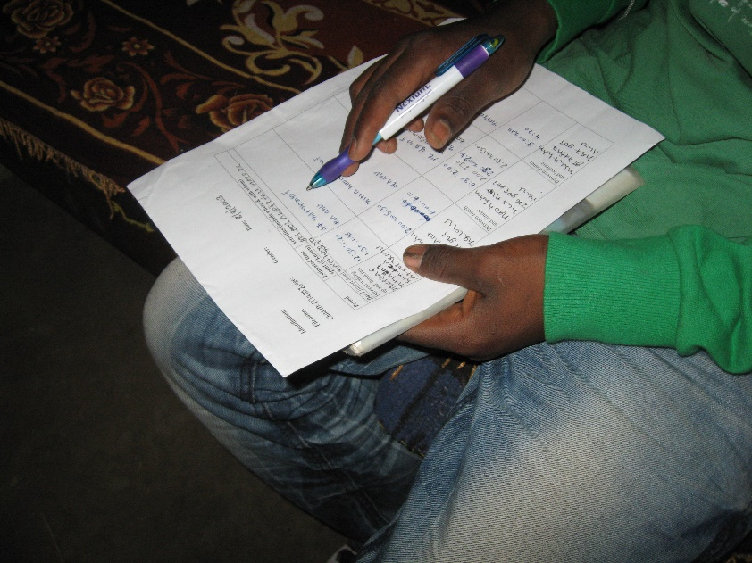

Other studies have combined diaries with other tools to facilitate children’s creation of ‘memory books’ or ‘life story books’. In Evans and Becker’s (2009) research on children caring for parents with HIV in Tanzania and the UK, they developed a life story book method called ‘My Story’ based loosely on the format of memory books [4], including sentence completion exercises, diary of a typical day, and spaces for drawing and collage. Other studies have used memory book techniques over longer periods of time to engage young people in self-documentation and reflection, as in the UK-based QLR project, Inventing Adulthoods (described in the previous section) where the memory book method was used alongside interviews with young people about their agency, values and identity in the transition to adulthood (Thomson and Holland 2005:202). In Inventing Adulthoods, the vision was that ‘memory books would be receptacles for memorabilia, materials that did not simply document a young person’s life (in the way that a journal or diary might) but which reflected the resources that they drew on in order to imagine themselves’ (ibid, p. 203). The young people were provided with a scrapbook, stickers with heading labels (‘adult’, ‘change’, ‘problems’, ‘sex’, ‘myself ’, ‘relationships’, ‘love’, ‘career’, etc.), folders and disposable cameras. They were told that they could: ‘write, draw, stick in photos, stick in magazine or newspaper cuttings, stick in things that remind you of something – tickets from events you have been to, postcards etc.’ (ibid, p. 205). Researchers distributed the memory books in the first round and they were used as prompts for discussion with those who had returned them in the second interview. Thomson and Holland (2005:217) offer some caution, however: ‘In much the same way as private letters and diaries, memory books are compelling, providing access into an extremely intimate space that has the danger of inciting voyeurism and a prurient fascination. It is then a continuing challenge to us to use the memory book data in an ethical way that honours the trust that young people placed in us by both creating them in the first place, and then sharing them with us.’

Drawing:
Drawing has become a favoured technique for researchers wishing to access children’s subjective experience of their worlds, and it can take many forms depending on the purpose and desired output. Scenario drawing was used by researchers investigating child poverty in Peru (Niños del Milenio/Young Lives) in four contrasting communities (Rojas and Cussianovich 2013). Children in the study were invited to participate in a ‘Wellbeing’ drawing exercise that aimed to generate indicators of child wellbeing and illbeing in their respective localities. [5] In the Peruvian child poverty study, this entailed each child drawing a scenario of a boy/girl who was doing well in life, and another image of a boy/girl who was not doing well. The drawings were presented in turn and discussed as a group, generating a list of wellbeing/illbeing indicators which the group ranked in the final stage of the discussion. This exercise was carried out in the same way in the first round (2007) and in the third round (2011), so analysis looked across time to changes in children’s perspectives (from age 12 to 16) and the factors contributing to change, such as life course transitions, and events occurring at the household and community level.

[Photo caption: Group of girls, 10 years-old, generating indicators of child wellbeing/illbeing in Peru, Young Lives, 2011]
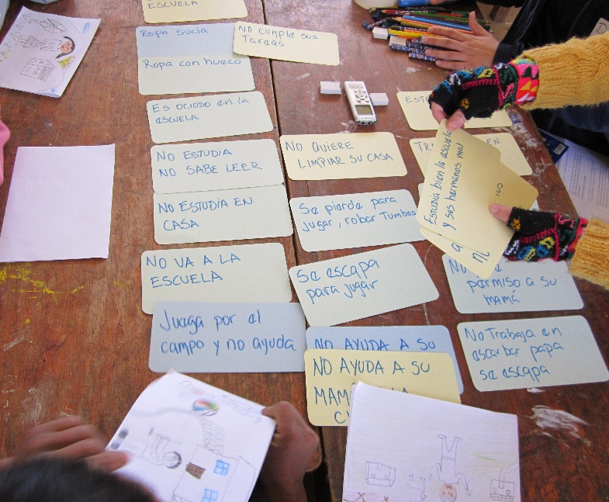

Generally speaking, providing younger children with materials to colour or draw may simply be a way to hold their attention when this is preferable for a research conversation (rather than the drawing being the core method). But drawing can also be an effective way of condensing and representing complex life processes and emotions that may otherwise be difficult to talk about (see for example, Evans 2004).

Relational maps:
Relational maps have been used to draw out children’s perspectives on the quality, significance and changing nature of their family and peer relationships, including identification of significant absences. Relational maps can prompt discussion around children’s social networks and who they turn to when they need help (e.g., with homework, to earn cash, for emotional support) and who they support in return. Researchers in the Young Lives and Times (YLT) study in England used relational mapping in their investigation of young people’s lives, identities and relationships, as part of the second round interview (in a ten-year prospective study) (Bagnoli 2009:555).
There are many options for creating relational maps, the main purpose being children’s identification of the individuals and groups that matter most to them. Some researchers prefer representation of the child in the centre of a series of concentric circles symbolising degrees of closeness/importance to the child (Josselson 1996). In the YLT study, young people were free to construct their maps as they wished, resulting in a variety of formats including spider diagrams, concentric circles, and bubbles and lines, and they identified individuals (‘mum and grandma’) and groups (‘my cadet friends’), including role models. The map is a prompt in the interview and can be used as a tool to identify and talk about those individuals who are absent from the map (e.g., due to migration or death or a falling out). The mapping exercise can be repeated in later rounds, used alongside timelines, or new methods can be developed to capture change and continuity in children’s relationships.

[Photo caption: A Relational Map drawn by ‘Sarada’, a 15 year-old girl in India, Young Lives, 2010]

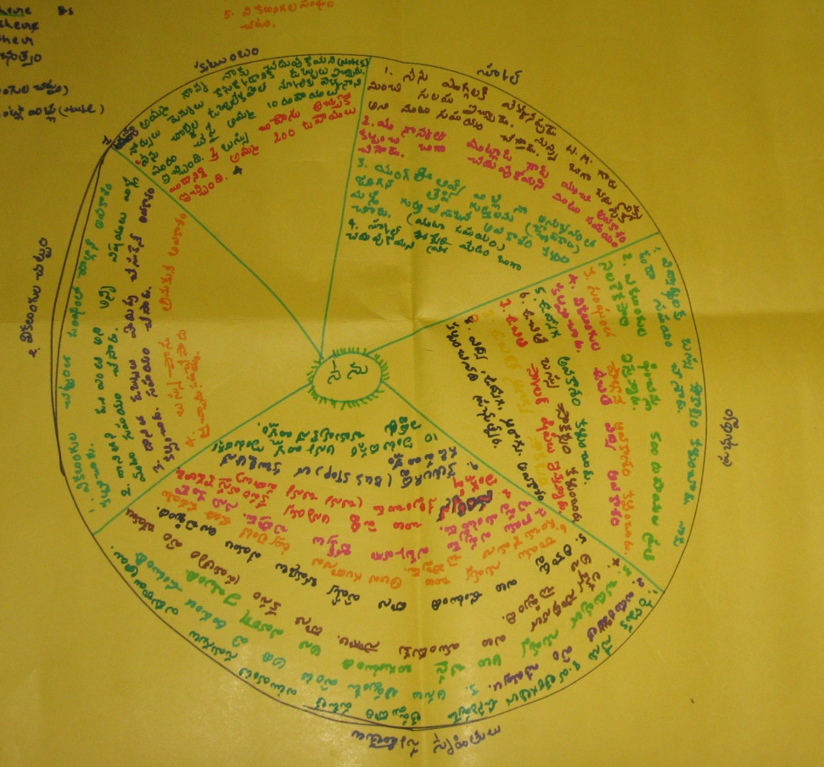
In the example (above) from Young Lives in India, 15 year-old Sarada depicted her social network in the form of a relational map. She included in her map both individuals (naming her closest friends and family) and institutional support, including School, as well as the Government and the Handicap association from which she received a stipend, free education and a bus pass, on account of her disability.

Storytelling, vignettes and newspaper clippings:

A variety of story-based methods including vignettes, story completion and the use of newspaper headlines or clippings can be included in QLR to elicit young people’s perceptions, assumptions and experiences of particular topics. Often carried out in focus groups (Hennessy and Heary 2005; Hill et al 1996), vignettes are stories of a hypothetical nature that can be presented to the group in one go (as a complete story) or in stages requiring participants to complete the story in turns.

Young Lives has used storytelling in the context of QLR to explore a variety of topics including children’s work in Ethiopia, adolescent social transitions in India, school transitions in Peru and peer bullying in Vietnam. For example, the following prompt was developed to explore the theme of school transitions with twelve year-old girls in Peru; the researcher began by saying:
Juliana is a girl who is in sixth grade of primary school. She likes to study but her parents have told her that she will not continue studying after finishing primary school because they need help at home. Juliana decided to talk to…
The children complete the story by answering open-ended questions posed by the facilitator to advance the story, such as ‘What will happen next?’, ‘What should [Juliana] do and why?’’ and ‘Who might help?’.

The hypothetical nature makes vignettes useful for exploring sensitive topics and topics for which participants do not have direct experience, however discussion prompts relating to actual events (in the community, country or world) may also stimulate discussion. For example, newspaper and magazine clippings or short documentary or news video clips can provide springboards to discussion where young people relate news items to their everyday lives and communities.

Variations of storytelling can be used across multiple waves of qualitative research, but researchers may need to adapt the topics and techniques to reflect changing ages of children and new research priorities. For example, when individuals are younger they may respond well to a story completion exercise, but in subsequent waves of research, and as they acquire adequate levels of literacy, they may prefer group discussion of newspaper headlines and news video clips.

Re-use, repetition, reflection
Whilst the first, baseline wave of data collection should utilize methods that generate robust, systematic and rich data, a flexible approach in QLR means that researchers need to be open and creative in planning subsequent rounds, responding to emergent findings, social and life course changes and ethical learning. The examples provided so far indicate the varied ways in which interviews can be combined with a variety of elicitation tools to capture children’s perspectives on different aspects of their lives and social worlds.
Certain techniques enhance the analytic potential and value of QLR, namely the re-use of materials (produced in an earlier round of research) in later rounds, and the repetition of specific methods across different rounds, these techniques aiding the capture of change and processes of reflection. Timelines, for example, ‘offer useful insights into life trajectories, plans and goals, and, used at each follow-up, the overwriting of biographies as lives unfold’ (Hanna and Lau-Clayton 2012). Revisiting timelines produced in earlier rounds enables discussion of how participants’ lives, circumstances and aspirations change, and their explanations, since the meanings given to the past may change over time.
In the Your Space! Siblings and Friends study in the UK, Weller (2012) used relational maps across three rounds (2002-2009), alongside the introduction of new methods (such as timelines in round 2). This demonstrates the way QLR methodology itself represents a negotiated process of continuity and change. Weller suggests that rather than evaluating individual techniques, QL researchers should focus on process and creativity:
One key advantage of qualitative longitudinal research is that it provides the time and space for constant reflection and innovation allowing researchers to hone in on and recognise the diversity and shifting nature of participants’ interests and popular cultures of communications (Weller 2012:130).
There is a further reason for researcher reflection, such that inviting young people to reflect on their past, present and future, and using personal material prompts from the past (photos, video, diaries, drawings), may produce feelings of regret or failure when participants feel that they have not lived up to (their own or others’) expectations. Ethical and methodological reflection go hand in hand.

QLR: Practical and ethical challenges
The promise of QLR is to generate rich temporal data and to illuminate the way individual biographies are shaped within social structures and processes. QL researchers draw on, and increasingly contribute to, the fruitful body of literature addressing the complex challenges inherent in social research with children (Alderson 1995; Alderson and Morrow 2004; Einarsdóttir 2007; Hill 1997; Morrow and Richards 1996; Tisdall et al 2009; Williamson et al 2005). The examples described so far have hinted at some of the practical and ethical challenges that sometimes arise due to particular methodological choices -- namely, whether and how to elicit the perspectives of children, which groups of children, for how long. These fundamental decisions are often made within the context of institutional constraints (e.g. university or disciplinary ethical guidelines and review boards) which may be at odds with researchers’ wishes to recognise children’s competence and their right to participation (Skelton 2008). In QLR, questions around ‘competence’ and ‘duty of care’ need to be revisited across time and space, and in light of young participants’ changing lives and development. This section concludes the chapter by briefly addressing two broad categories of challenges that arise in QLR with children: the first pertains to ‘data, analysis and logistics’, and the second, to ‘research relationships and reciprocity’.
QLR gives rise to complex challenges around data, analysis and logistics. QLR is expensive and unlike non-longitudinal/ cross-sectional studies, may require additional resources related to tracking the sample between rounds of data collection, as well as the costs associated with management of large and evolving data sets, research staff and ongoing project websites, over long time periods. The complexity and quantity of data increase with each new round, demanding that orderly data management systems be put in place early on and maintained over time. An increasingly large QL data set poses practical questions about how to ‘enter’ the data analytically (case-wise, through thematically coded data, etc.), and how to integrate both cross-sectional and temporal dimensions of analysis. Thomson and Holland (2003) bring to light what they consider, ‘the most challenging aspect of this kind of data set…the absence of analytic closure, with new rounds of data always threatening to render interpretations redundant’ (p. 243). Much in the same way QL researchers invite their young participants to reflect on (textual and visual) materials produced in earlier rounds, the analytic process in QLR demands a constant ‘looking back’ and the potential to cast new (and re-)interpretations on the data (and analyses). In the Young Lives study and majority of QLR, children are not directly involved in data analysis or dissemination, since involving them in these processes might be viewed as an ‘intervention’ while the study is ongoing.

A further consideration stems from the increased expectation (by funders and within the research community) to publicly archive QL data; this poses many questions related to the ethics of secondary analysis and data sharing, including confidentiality, and the need to achieve contextual understanding of qualitative data by analysts not involved in data collection (Neale and Bishop 2012; Morrow et al 2014). Additionally, the preparation and anonymisation of QL data for public use can be both time-consuming and costly.
Qualitative research favours small sample sizes, and in QLR this poses a particular challenge regarding attrition, since the tracking of research participants can span years or even decades. Young people may lose interest in participating (‘respondent fatigue’), migrate, or lack the means to stay in touch (telephone/email). At the same time, retaining fieldworkers across rounds may prove difficult (e.g., if they are on short-term contracts or move on to new jobs), despite their crucial role in establishing and maintaining rapport with participants.

Researchers wishing to implement QLR may face initial funding constraints, and some studies begin as a ‘one-off’ process but develop into QLR as time and resources become available (see Punch 2012, above). This can create a sense of uncertainty for researchers and participants when each subsequent wave of data collection requires renewed efforts to secure funding. Such indeterminacy also creates difficulties for researchers wishing to convey accurate messages to participants about their potential roles in future phases of research, and information about possible return visits.

Indeed, the management of research relationships is a fundamental process within QLR. Neale argues that ‘adding time into the mix’ of a qualitative study heightens the need for ethical literacy (2013:6). Maintaining confidentiality becomes increasingly difficult when publishing detailed personal accounts of children’s lives over time, and when sharing findings and visual images through social media and project websites. Obtaining informed consent (or ‘assent’) from participants is also ongoing (as it often is in non-longitudinal qualitative studies). In QLR, however, informed consent needs to be revisited over the course of research, rather than being seen as a ‘one-off’ process, since new research questions and methods may alter the nature of participation across different phases of the study.
Research can have unintended effects on young participants (recall the opening quote to the chapter), and the nature and quality of QL data may be influenced by children’s increasing familiarity with the ‘research process’ and with what it means to assume the role of ‘research participant’. The repeat interview format can have a normative effect, as pointed out by Holland and Thomson (2003:242), such that young people become accustomed to reflecting on their past and talking about their imagined futures, possibly inclining them to produce narratives of progress and development.
The nature of research relationships in QLR is a dynamic and negotiated process in time: children’s (and families’) expectations about the study and about their relationships with researchers can change. For example, Young Lives investigates childhood poverty across numerous resource-poor communities, and in some of them, there is also a heavy presence of NGO and humanitarian organisations (see Morrow 2009). Early on, some participants confused Young Lives (a non-interventionist research programme) for an NGO, and over a decade on, the nature and purpose of the study continue to be explained at each round of survey and qualitative research. Of course, research encounters take place with particular families, in specific cultures and societies, framed by local understandings of what sharing, reciprocity, trust and obligation mean. This gives rise to dilemmas in the field, when researchers are asked by families to become godparents or ritual siblings, to share personal telephone numbers, email addresses and Facebook invitations, or to advise and provide assistance to children so that they can access schooling or jobs, or migrate to the city or abroad.

Field teams agree ahead of time how they should respond tactfully to such requests so that there is a consistent response in line with the wider Young Lives approach. However, it is not so straightforward in practice. Some researchers express discomfort with the constraints placed on their roles as researchers and would prefer to (and in some instances, did) accept invitations to deepen their relationships with particular families, beyond that required for the research. In a personal capacity, they stay in touch with families and some have even given small gifts outside of the context of research (although this is not part of their agreed research role). This can be a problem for the study if it generates tensions between participants, since some children may be seen to receive special attention and resources not enjoyed by others. Indeed, despite carefully designed ethical guidelines, maintaining a non-interventionist approach in long-term research with vulnerable children and families presents complex ethical challenges for all those involved. Young Lives anticipated these dilemmas would be important to capture and learn from, so the study included a separate code (‘Relationships with Young Lives’) that is applied when coding interview transcripts across rounds of research.

Conclusion
There is growing interest in the potential value of qualitative longitudinal research, both as a methodological approach and as a means of informing social policies. QLR developed as part of the ‘temporal’ turn in the social sciences, reflecting a desire to deepen understanding of social phenomena in greater time perspective (Thomson et al 2014: 2). QLR brings to geographies of children and young people the potential to explore in more depth time-space dimensions of young people’s experiences and their dynamic contexts, at differing scales.
Geographers’ approach to studying children and young people has been shaped in recent decades through engagement with the new social studies of childhood (James, Jenks and Prout 1998), bringing with it a focus on children’s life worlds, often employing ethnographic methods; this has resulted in what some have described as ‘an overwhelming emphasis on different children’s micro-geographies at the expense of a macro analysis’ (Holloway 2014; also see Abebe 2015 and Ansell 2009). As a methodology, QLR can contribute to the ‘scaling up’ of small-scale qualitative research by potentially extending the temporal, spatial and disciplinary horizons of research, including in ways that are relevant for policy.
Indeed, current policy directions signal increasing awareness of temporal considerations, particularly at global level where concerns around sustainability, growing inequalities and the life course have given rise to calls for a ‘data revolution’ and for establishing new longitudinal cohort studies and collaborations. Thomson and colleagues (2014: 1) suggest that QLR offers deep data to the ‘big data’ debates, as well as a particular ‘sensibility’ to time and reflexivity. Within the current policy landscape, QLR offers a space for multidisciplinary collaboration, methodological innovation, ethical learning and the meaningful participation of children and young people in research about their lives.
Whilst not all research questions require a qualitative or longitudinal design - or the participation of children for that matter - some questions and topics are particularly well-suited to a QLR approach, and benefit from children’s knowledge. For example, QLR is well-suited to address the complexities of poverty dynamics, to identify links between earlier circumstances and later outcomes, to examine the relationship between geographic and social mobility, and to explore when, why and how inequality emerges in childhood and youth (Morrow and Crivello 2015). This chapter offers a selection of methods that can be adopted and developed to generate temporal data with children and youth on differing aspects of their lives. Despite the practical and ethical challenges arising from young people’s involvement in QLR, there remain important ‘scientific, moral, political and pragmatic’ reasons for involving them in research about their changing lives and contexts (Greene and Hill 2005:18).

Endnotes
1. For information on Timescapes see http://www.timescapes.leeds.ac.uk/index.html.
2. For information on Young Lives see www.younglives.org.uk.
3. The three studies were: (1) Youth Values: A study of identity, diversity and social change; (2) Inventing Adulthoods: Young people’s strategies for transition; and, (3) Youth Transitions.
4. Memory books were developed by the National Community of Women Living with HIV and AIDS in Uganda and have been used in families affected by HIV in Eastern and Southern Africa.
5. A description of the tool and a case study of how it was used in Young Lives, Peru, can be found in Johnson et al 2014. The ‘Wellbeing Exercise’ was originally developed by Jon Hubbard whilst at the Center for Victims of Torture in Minneapolis, Minnesota (USA), and Armstrong and colleagues used the tool effectively with adolescents in Sri Lanka. See: Armstrong, M., Boyden, J. Galappatti, A. and Hart, J. (2004) Piloting Methods for the Evaluation of Psychosocial Programme Impact in Eastern Sri Lanka, Final Report for the USAID, Oxford: Oxford Refugee Studies Centre.

References
Adam, B., Hockey, J., Thompson, P. and Edwards, R. (2008) Researching lives through time: Time, generation and life stories, Timescapes Working Paper Series No. 1.
Abebe, T. (2015) Reframing children's contributions to household livelihoods in Ethiopia through a political-economy perspective, in A. Pankhurst, M. Bourdillon and G. Crivello (eds.), pp. 19-40. Addis Ababa: Organisation for Social Science Research in Eastern and Southern Africa.
Abebe, T. (2008a) Trapped between disparate worlds? The livelihoods, socialisation and school contexts of rural children in Ethiopia. Childhoods Today 2(1): 1-29.
Abebe, T. (2008b) Ethiopian childhoods: A case study of the lives of orphans and working children. PhD Thesis, Norwegian University of Science and Technology, Department of Geography, Norwegian Centre for Child Research.
Aitken, S.C. (2001) Geographies of young people: the morally contested spaces of identity. London: Routledge.
Alderson, P. (1995) Listening to children: Children, ethics and social research. London: Barnardo’s.
Alderson, P. & Morrow, V. (2004): Ethics, Social Research and Consulting with Children and Young People. London: Barnardos.
Anderson, J. (2007) Urban poverty reborn: A gender and generational analysis. Journal of Developing Societies, 23(1-2): 221-241.
Ansell, N., van Blerk, L., Hajdu, F. and Robson, E. (2011) Spaces, times and critical moments: A relational time-space analysis of the impacts of AIDS on rural youth in Malawi and Lesotho. Environment and Planning, 43:525-544.
Bagnoli, A. (2009) beyond the standard interview: The use of graphic elicitation and arts-based methods, Qualitative Research, 9(5): 547-570.
Barter, C. and Renold, E. (2000) ‘I wanna tell you a story’: Exploring the application of vignettes in qualitative research with children and young people. International Journal of Social Research Methodology, 3: 307-323.
Blytheway, B. (2012) The use of diaries in qualitative longitudinal research, Timescapes Methods Guides Series, Guide No. 7.
Boyden, J. and Ennew, J. (1997) Children in Focus: A Manual on Child-centred Participatory Research, Stockholm: Rädda Barnen.
Broström, S. ( 2005) Children’s perspectives on their childhood experiences, in J. Einarsdottir and J. Wagner (eds.) Nordic Childhoods and Early Education: Philosophy, Research, Policy and Practice in Denmark, Finland, Iceland, Norway, and Sweden, pp. 223-56. Greenwich, CT: Information Age.

Bryman, A. (2004) Social Research Methods (2nd ed.), Oxford: Oxford University Press.
Clark, A. (2005) Listening to and involving young children: a review of research and practice', Early Child Development and Care, 175(6): 489-505.

Clark, A., Flewitt, R., Hammersley, M. and Robb, M. (2014) Understanding Research with Children and Young People, London: SAGE Publications Ltd.
Clark, J and Fox, T (2012) Conducting evaluation research using Ql and QNL methods. Timescapes Methods Guides Series 2012. Guide No. 14.
Cole, J. and Durham, D. (2008) Introduction: Globalization and the temporality of children and youth, In J. Cole and D. Durham [eds.] Figuring the future: Globalization and the Temporalities of Children and Youth. Santa Fe, NM: School for Advanced Research Press.
Crivello, G., Morrow, V., Wilson, E. (2013) Young Lives Longitudinal Qualitative Research: a guide for researchers. Young Lives Technical Note 26, Young Lives, Oxford.
Einarsdóttir, J. (2007) Research with children: Methodolgoical and ethical challenges, European Early Childhood Education Research Journal, 15(2): 197-211.
Emond, R. (2005) Ethnographic research methods with children and young people, in S. Greene and D. Hogan (eds.), Researching children’s experience: Approaches and methods. pp. 123-139. Abingdon (UK): Routledge.
Elliot, H. (1997) ‘The use of diaries in sociological research on health experience’, Sociological Research Online, 2(2).

Evans, R. (2004) ‘Tanzanian childhoods: street children’s narratives of home’, Journal of Contemporary African Studies, 22 (1): 69-92.

Evans, R. and Becker, S. (2009) Children Caring for Parents with HIV and AIDS: Global Issues and Policy Responses, The Policy Press: Bristol.

Gabb, J. (2008) Researching intimacy in families, London: Palgrave.

Greene, S. and Hill, M. (2005) Researching children’s experience: Methods and methodological issues, in S. Greene and D. Hogan (eds.), Researching children’s experience: Approaches and methods. pp. 123-139. Abingdon (UK): Routledge.

Guenette, F. and Marshall, A. (2009) Time line drawings: Enhancing participant voice in narrative interviews on sensitive topics, International Journal of Qualitative Methods, 8(1): 85-92.

Hanna, E. and Lau-Clayton, C. (2012) Capturing past and future time in qualitative longitudinal field enquiry: Timelines and relational maps, Timescapes Methods Guides Series, Guide No. 5.
Hay, C. (2002) Political Analysis: A Critical Introduction, Basingstoke: Palgrave.
Hennessy, E. and Heary, C. (2005) Exploring children’s views through focus groups, in S. Greene and D. Hogan (eds.) Researching Children’s Experience: Approaches and Methods, London: Sage.
Henwood, K. and Shirani, F. (2012) Extending temporal horizons, Timescapes Methods Guides Series 2012, Guide No. 4.
Hill, M. (1997) Participatory research with children, Child and Family Social Work, 2(3): 171-183.
Hill, M., Laybourn, A., and Borland, M. (1996) Engaging with primary-aged children about their emotions and well-being: Methodological considerations, Children and Society, 10(2): 129–144.
Holland, J., Thomson, R. and Henderson, S. (2004) Feasibility study for a possible qualitative longitudinal study: Discussion paper. www.lsbu.ac.uk/inventingadulthoods/feasibility_study.pdf
Holloway, S.L. and Valentine, V. G. (2000) Spatiality and the new social studies of childhood, Sociology, 34:763-783.
James, A., Jenks, C. and Prout, A. (1998) Theorizing Childhood. Cambridge: Polity Press.
Johansson, A., Brunnberg, E. and Eriksson, C. (2007) Adolescent Girls’ and Boys’ Perceptions of Mental Health, Journal of Youth Studies, 10(2): 183-202.
Johnson, V., Hart, R. and Colwell, J. (eds.) (2014) Steps to Engaging Young Children in Research: The Guide and Toolkit, The Hague: The Bernard van Leer Foundation and Brighton: University of Brighton.
Josselson, R. (1996) The space between us: Exploring the dimensions of human relationships. London: Sage.
Katz, C. (2004) Growing Up Global: Economic Restructuring and Children’s Everyday Lives. Minneapolis, MN: University of Minnesota Press.
Laub, J.H., and Sampson, R.J. (2003) Shared beginnings, divergent lives: Delinquent boys to age 70. Cambridge: Harvard University Press.
Lewis, J. (2007) Analysing qualitative longitudinal research in evaluations, Social Policy and Society, 6(4): 545-556.
Lyon, D. and Crow, G. (2012) The challenges and opportunities of re-studying community on Sheppey: young people’s imagined futures. Sociological Review, 60 (3): 498-517.
Macmillan, R. (2011) Seeing things differently? The promise of qualitative longitudinal research on the third sector, Third Sector Research Centre, Working Paper 56
Mayall, B. (2002) Towards a Sociology for Childhood. Buckingham, UK: Open University Press.
Mead, M. (1928) Coming of age in Samoa: A psychological study of primitive youth for western civilization. New York: William Morrow.
Millar, J. (2007) The dynamics of poverty and employment: The contribution of qualitative longitudinal research to understandings transitions, adaptations and trajectories, Social Policy and Society, 6(4): 533-544.
Morrow, V. (2001) Using qualitative methods to elicit young people's perspectives on their environments: some ideas for community health initiatives, Health Education Research: Theory and Practice, 16(3): 255-268.
Morrow, V. (2009) The ethics of social research with children and families in Young Lives: Practical experiences. Working Paper 53, Oxford: Young Lives.
Morrow, V. and Crivello, G. (2015) What is the value of qualitative longitudinal research with children and young people for international development?, International Journal of Social Research Methodology, 18(3): 267-280.

Morrow, V. and Richards, M. (1996) The ethics of social research with children: An overview, Children & Society, 10: 90-105.

Morrow, V., Boddy, J. and Lamb, R. (2014) The ethics of secondary data analysis: Learning from the experience of sharing qualitative data from young people and their families in an international study of childhood poverty, NOVELLA Working Paper:
Narrative Research in Action.
Neale, B. (2012) Qualitative longitudinal research: An introduction to the Timescapes methods guides series, Timescapes Methods Guides Series 2012, Guide No. 1.

Neale, B. (2013) Adding time into the mix: Stakeholder ethics in qualitative longitudinal research, Methodological Innovations Online, 8(2): 6-20.

Neale, B. and Bishop, L. (2012) The ethics of archiving and re-using qualitative longitudinal data: A stakeholder approach. Timescapes Methods Guide Series, Guide No. 18.

Neale, B., & Flowerdew, J. (2003) Time, texture and childhood: the contours of longitudinal qualitative research. International Journal of Social Research Methodology, 6(3): 189-199.

Punch, S. (2001) Multiple methods and research relations with young people in
rural Bolivia, in M. Limb and C. Dwyer (eds) Qualitative Methodologies for
Geographers, pp.165-180, London: Arnold.

Punch, S. (2012) Studying transnational children: A multi-sited, longitudinal, ethnographic approach. Journal of Ethnic and Migration Studies, 38(6):1007-1023.

Qvortrup, J. (1994) ‘Childhood matters: an introduction’, in J. Qvortrup, M. Bardy, G. Sgitta and H. Wintersberger (eds.) Childhood Matters: Social Theory, Practice and Politics, pp. 1-24, Aldershot: Avebury.

Ridge, T. and Millar, J., (2011) Following families: working lone-mother families and their children, Social Policy & Administration, 45(1): 85-97.

Saldaña, J. (2003) Longitudinal qualitative research: Analyzing change through time, Walnut Creek, CA: AltaMira Press.
Rojas, V. and Cussianovich, A. (2013) ‘Le va bien en la vida: cambios y permanencias en el bienestar subjetivo de un grupo de adolescentes en Perú’, Lima: GRADE; Niños del Milenio, Documento de Trabajo.
Skelton, T. (2008) Research with children and young people: exploring the tensions between ethics, competence and participation, Children's Geographies, 6(1): 21-36.
Tafere, Y., Abebe, W., and Assazenew, A. (2013) Young Lives Qualitative Research: Round 1 - Ethiopia, Young Lives Technical Note No. 19.
Theis, J. (1996) Children and participatory appraisals: experiences from Vietnam, PLA Notes, 25: 70-72, London: IIED
Tisdall, K., Davis, J., & Gallagher, M. (2009) Researching with children and young people. London: Sage Publications.
Thomson, R. (2007) The qualitative longitudinal case history: practical, methodological and ethical reflections, Social Policy and Society, 6(4): 571-582.
Thomson, R., Hadfield, L., Holland, J., Henwood, K., Moore, N. Stanley, L. and Taylor, R. (2014) new Frontiers in QLR: Definition, design and display, NCRM Working Paper, NCRM.
Thomson, R. and Holland, J (2003) Hindsight, foresight and insight: the challenges of longitudinal qualitative research, International Journal of Social research Methodology, 6(3): 233-244.
Thomson, R. and Holland, J. (2005) 'Thanks for the memory': memory books as a methodological resource in biographical research, Qualitative Research, 5(2): 201-219.

Thomson, R., Hadfield, L., Kehily, MJ. And Sharpe, S. (2012) Acting up and acting out: Encountering children in a longitudinal study of mothering. Qualitative Research, 12(2): 186-201.

van Blerk, L. and Kesby, M. (2009) Doing children's geographies: Methodological issues in research with young people. Abingdon (UK): Routledge.
Varga-Atkins, T. and O’Brian, M. (2009) From drawings to diagrams: Maintaining researcher control during graphic elicitation in qualitative interviews, International Journal of Research and Method in Education, 32(1):53-67.
Veale, A. (2005) Creative methodologies in participatory research with children, in S. Greene and D. Hogan (eds.), Researching children’s experience: Approaches and methods, pp. 253-272, Abingdon (UK): Routledge.

Walker, C. (forthcoming). Photo elicitation as part of a multi-method research design: Family lives and the environment in Andhra Pradesh, India. Sage Research Methods Online Handbook. Available to view at http://srmo.sagepub.com/cases

Weller, S. (2012) Evolving creativity in qualitative longitudinal research with children and teenagers, International Journal of Social Research Methodology, 15(2): 119-133.

Werner, E.E. and Smith, R.S. (1995) Overcoming the odds: High risk children from birth to adulthood. New York: Cornell University Press.

Werner, E.E. and Smith, R.S. (2001) Journeys from childhood to midlife: Risk, resilience, and recovery, New York: Cornell University Press.

Williamson, E., Goodenough, T., Kent, J. and Ashcroft, R. (2005) Conducting research with children: The limits of confidentiality and child protection protocols, Children and Society, 19(5): 397-409.

Wilson, I. and Huttly, S. (2003) Young Lives: A Case Study of Sample Design for Longitudinal Research, Young Lives Working Paper No. 10.

Worth, N. (2009) Understanding youth transition as `becoming': identity, time and futurity, Geoforum, 40:1050-1060.

Wright, J., O’Flynn, G. and Macdonald, D. (2006) Being fit and looking healthy: Young women’s and men’s constructions of health and fitness, Sex Roles, 54: 707-716.

